Calvin Tucker

6/23/2024

Professor Wetsch

Final Project Part II Submission

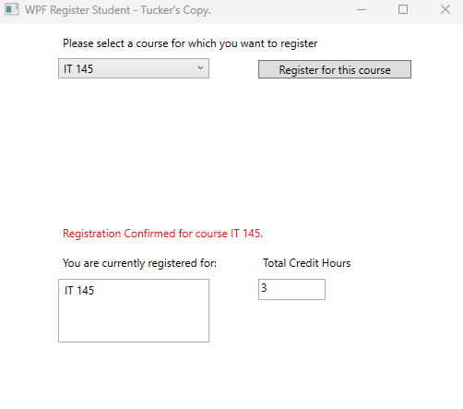

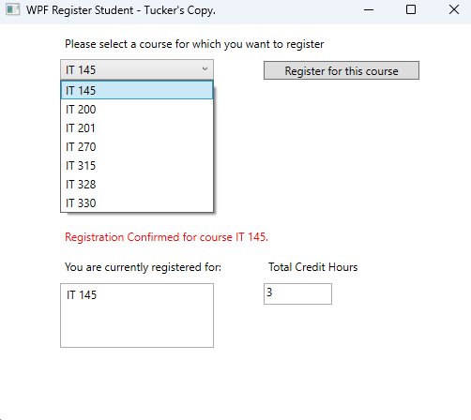

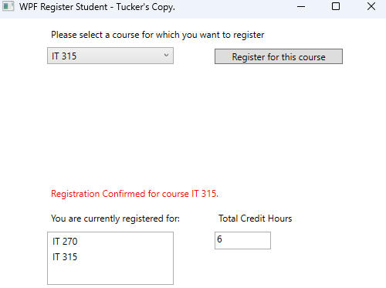

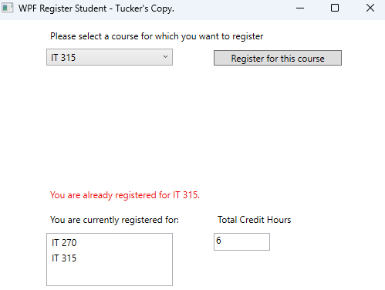

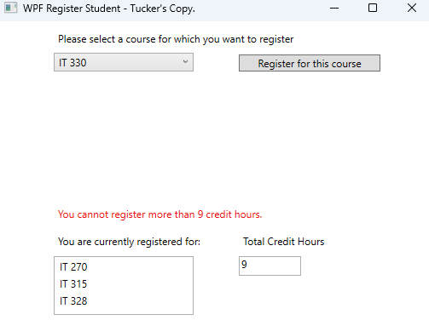

**SCREENSHOT DESCRIPTIONS**

Screenshot 1:

Showcases the functionality of valid registration.

Screenshot 2:

Showcases that all the courses were added properly to the ComboBox.

Screenshot 3:

Showcases that the Total credit hours are being added up properly based on how many courses are registered for.

Screenshot 4:

Showcases the warning when attempting to register for the same course.

Screenshot 5:

Showcases the warning after reaching the maximum amount of credit hours.

**SOURCE CODE**

using System;

using System.Collections.Generic;

using System.Linq;

using System.Text;

using System.Threading.Tasks;

using System.Windows;

using System.Windows.Controls;

using System.Windows.Data;

using System.Windows.Documents;

using System.Windows.Input;

using System.Windows.Media;

using System.Windows.Media.Imaging;

using System.Windows.Navigation;

using System.Windows.Shapes;

namespace WPFRegisterStudent

{

/// <summary>

/// Interaction logic for MainWindow.xaml

/// </summary>

public partial class MainWindow : Window

{

Course choice; // choice.

int credits = 0; // set credits.

public MainWindow()

{

InitializeComponent();

Title = "WPF Register Student - Tucker's Copy."; // title of the window.

}

private void Window_Loaded(object sender, RoutedEventArgs e)

{

// add courses name.

Course course1 = new Course("IT 145");

Course course2 = new Course("IT 200");

Course course3 = new Course("IT 201");

Course course4 = new Course("IT 270");

Course course5 = new Course("IT 315");

Course course6 = new Course("IT 328");

Course course7 = new Course("IT 330");

// set courses to combobox.

this.comboBox.Items.Add(course1);

this.comboBox.Items.Add(course2);

this.comboBox.Items.Add(course3);

this.comboBox.Items.Add(course4);

this.comboBox.Items.Add(course5);

this.comboBox.Items.Add(course6);

this.comboBox.Items.Add(course7);

this.textBox.Text = "";

}

private void button_Click(object sender, RoutedEventArgs e)

{

bool itemChoice = false;

choice = (Course)(this.comboBox.SelectedItem);

foreach (var item in this.listBox.Items)

{

if (item.ToString() == choice.ToString())

{

itemChoice = true;

}

}

// validate user selection (the choice object)

if (choice != null && itemChoice == false && credits < 9)

{

this.listBox.Items.Add(choice);

credits += 3; // add total credits

label3.Content = "Registration Confirmed for course " + choice.ToString() + "."; // output to the user that the course has been signed up for

this.textBox.Text = credits.ToString(); // set credits to textbox text

}

else

{

if(credits >= 9)

{

label3.Content = "You cannot register more than " + credits.ToString() + " credit hours."; // output warning to the user if the credits reached is 9.

}

else

{

label3.Content = "You are already registered for " + choice.ToString() + "."; // output to the user if they attempted to sign up for the same course.

}

}

}

}

}